SIMATS ENGINEERING (SAVEETHA SCHOOL OF ENGINEERING)
Department of Artificial Intelligence and Data Science
ASSESSMENT TOOL 1 – Experiments

Course Code: | DSA03 | Course Title: | Natural Language Processing
CO Assessed: | CO3 – Precision | Assessment: | Assessment Tool 1 – Experiments
Weightage: | 50% of CIA
CO5 Statement: | Apply N-gram models, smoothing techniques, part-of-speech tagging systems and to evaluate effective syntactic analysis. (BL-3)
Student Name: | T.Nikhitha | Reg. No.: | 192424114
Section / Batch: | AI&DS 2024-2028 | Date: | 7-08-2026

Code of Conduct
I _T.Nikhitha-192424114_ (Name / Reg No) certify that this submission is my original work and that I have adhered to the guidelines specified for this assessment. I understand that any violation of academic integrity rules will result in disciplinary action.
Signature of the Student: __T.Nikhitha__

Instructions
- Perform all experiments using Google Colab.
- Create a separate notebook (.ipynb) for the assessment.
- Ensure all code is executable without errors.
- Include appropriate comments explaining the logic used.
- Complete all three experiments in a single Google Colab notebook.
- Execute all cells and display the outputs for the given test cases.
- Save the notebook with the naming convention: RegNo_Name_CO3-AT1.ipynb
- Upload the notebook to your GitHub repository.
- Ensure the repository is public or accessible to the instructor.
- Submit the following:
- GitHub Repository Link in GCR
- Google Colab Share Link in GCR
- Screenshots of uploaded coding and output files as printout.
- Duration: 30 minutes.

Section / Topic | Focus |  | Experiment Questions
Context-Free Grammars for English Syntax, Context-Free Rules and Trees, Sentence-Level Constructions, Parsing, Top-Down Parsing, Earley Parsing |  | Design a Python program to validate sentences using CFG production rules and construct parse tree representations for valid sentences. | Q1
Agreement, Feature Structures, Sub Categorization |  | Design a Python program to verify subject–verb agreement and validate grammatical constraints using feature structures and subcategorization rules. | Q2
Probabilistic Context-Free Grammars (PCFGs) |  | Design a Python program to parse sentences and compute sentence probabilities using probabilistic grammar production rules. | Q3

Annexure A – Experiments

Experiment 1: Context-Free Grammar Rule Validation and Parse Tree Construction

Experiment Description
Design a Python program to validate whether a sentence follows the given Context-Free Grammar (CFG) rules and generate its parse tree representation.
Grammar:
S → NP VP
NP → Det N
VP → V NP
Det → the | a
N → student | teacher | book
V → reads | likes

Task
- Accept a sentence as input.
- Verify whether it conforms to the CFG.
- Construct and return the parse tree.
- Return "Invalid Sentence" if parsing fails.

Function Prototype
def parse_cfg(sentence):
pass

Test Cases
Input | Expected Output
the student reads a book | Valid Parse Tree
a teacher likes the book | Valid Parse Tree
student reads book | Invalid Sentence
the book likes a teacher | Valid Parse Tree
reads the student book | Invalid Sentence

Experiment 2: Agreement and Feature Structure Checking

Experiment Description
Design a Python program that verifies subject–verb agreement using feature structures containing Number and Person attributes.

Feature Rules
he → singular, third person
she → singular, third person
it → singular, third person
they → plural
runs → singular verb
writes → singular verb
run → plural verb
write → plural verb

Task
- Accept Subject and Verb.
- Compare feature structures.
- Return True if agreement holds.
- Return False otherwise.

Function Prototype
def check_agreement(subject, verb):
pass

Test Cases
Subject | Verb | Expected
he | runs | True
he | run | False
they | run | True
they | writes | False
she | writes | True

Experiment 3: Probabilistic Context-Free Grammar (PCFG) Parsing

Experiment Description
Implement a Python program to compute the probability of a sentence using the given PCFG.

Grammar
S → NP VP [1.0]
NP → John [0.6]
NP → Mary [0.4]
VP → runs [0.5]
VP → walks [0.5]

Probability Formula
P(Sentence)
=
P(S→NP VP)
× P(NP)
× P(VP)

Task
- Accept a two-word sentence.
- Parse using the PCFG.
- Compute sentence probability.
- Return 0 if sentence cannot be generated.

Function Prototype
def sentence_probability(sentence):
pass

Test Cases
Input Sentence | Expected Probability
John runs | 0.30
John walks | 0.30
Mary runs | 0.20
Mary walks | 0.20
Peter runs | 0.00

Experiment 1: Context-Free Grammar (CFG) Rule Validation and Parse Tree Construction
Aim
To design and implement a Python program that validates whether an input sentence follows the given Context-Free Grammar (CFG) production rules and constructs its parse tree representation.
Theory
A Context-Free Grammar (CFG) is a collection of production rules that describe the syntax of a language. It is widely used in Natural Language Processing (NLP) for parsing English sentences and verifying grammatical correctness.
Given Grammar
S → NP VP
NP → Det N
VP → V NP
Det → the | a
N → student | teacher | book
V → reads | likes
A sentence is considered valid only if it satisfies the above grammar rules.
Algorithm
- Import the required NLTK modules.
- Define the CFG using production rules.
- Accept a sentence from the user.
- Tokenize the sentence.
- Parse the sentence using the ChartParser.
- If parsing succeeds:
  - Display "Valid Sentence".
  - Generate and display the parse tree.
- Otherwise display "Invalid Sentence".

Python Code and output
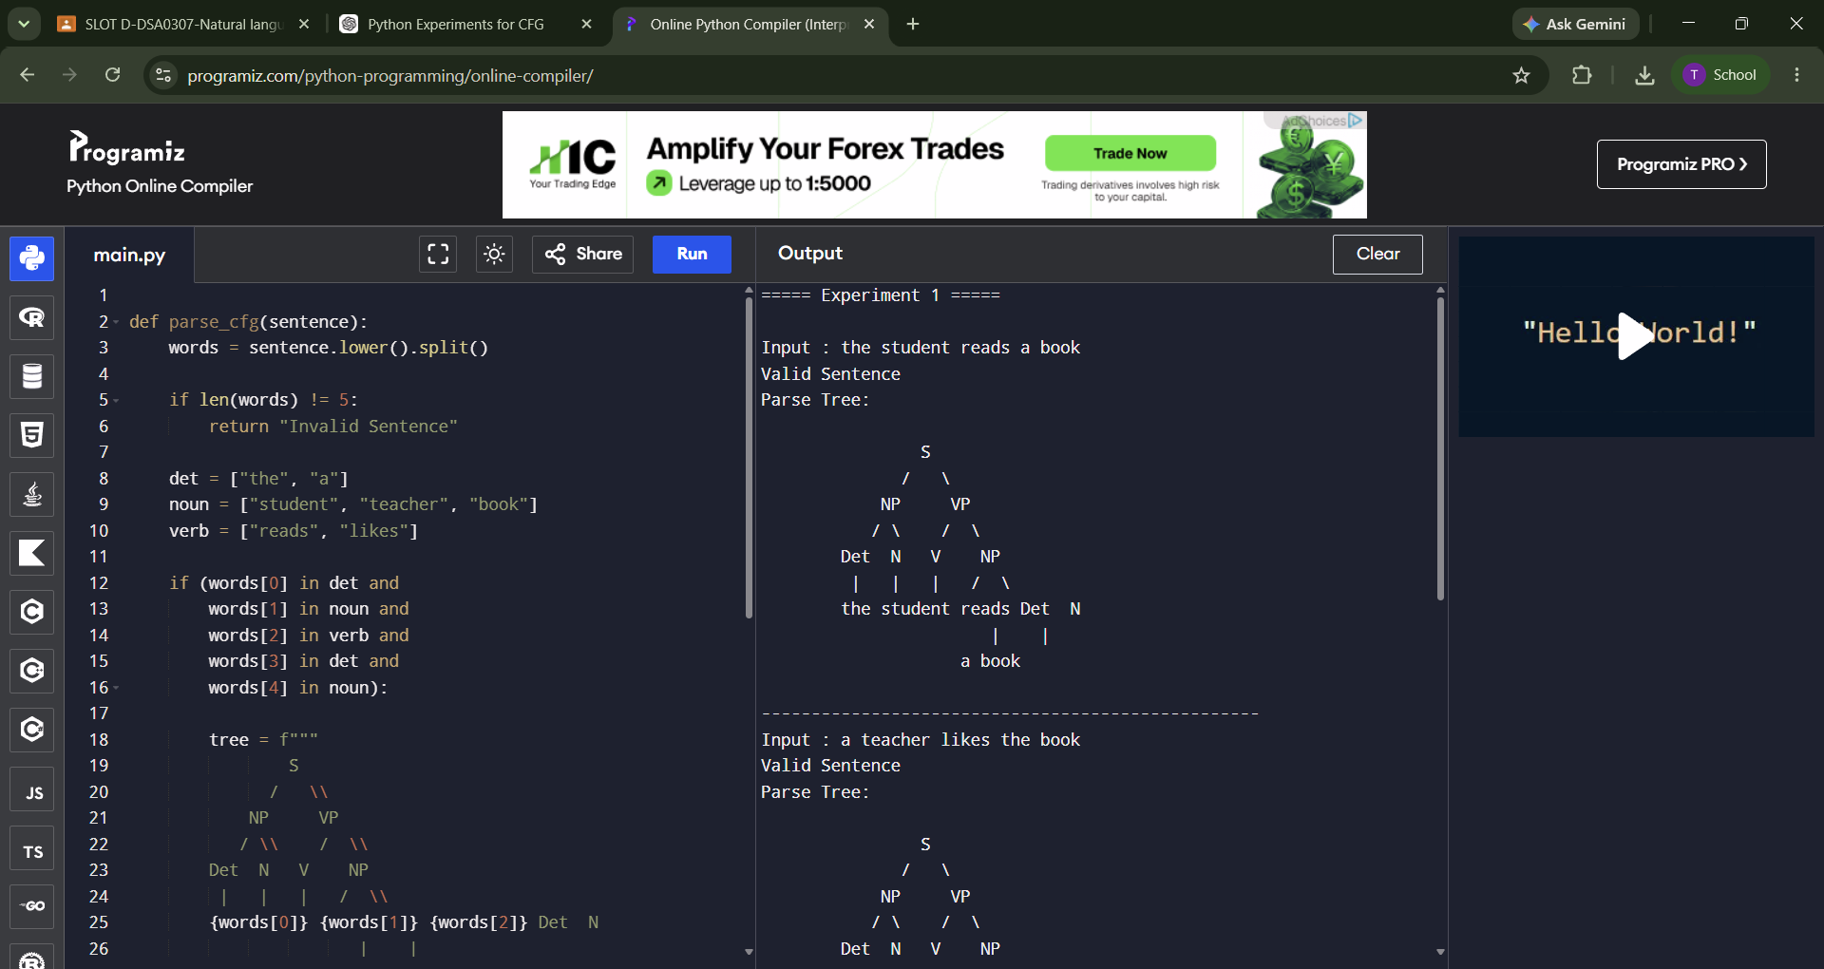

Test Cases
Input | Output
the student reads a book | Valid Parse Tree
a teacher likes the book | Valid Parse Tree
student reads book | Invalid Sentence
the book likes a teacher | Valid Parse Tree
reads the student book | Invalid Sentence

Result Analysis
- The parser successfully validates grammatically correct sentences.
- Invalid sentences fail because they do not follow the CFG production rules.
- Parse trees visually represent the syntactic structure of valid sentences.
- CFG helps improve syntactic analysis in NLP applications such as machine translation and grammar checking.

Conclusion
The experiment successfully validates English sentences using CFG rules and constructs parse trees. It demonstrates how syntax analysis can be performed automatically in Natural Language Processing.

Experiment 2: Subject–Verb Agreement using Feature Structures

Aim
To develop a Python program that verifies subject–verb agreement using feature structures based on Person and Number.

Theory
Feature structures store grammatical information like:
- Person
- Number
- Gender (optional)
The agreement checker compares the subject features with the verb features to determine whether the sentence is grammatically correct.
Feature Rules
Subject | Feature
he | Singular, Third Person
she | Singular, Third Person
it | Singular, Third Person
they | Plural

Verb | Feature
runs | Singular
writes | Singular
run | Plural
write | Plural

Algorithm
- Define dictionaries for subject features.
- Define dictionaries for verb features.
- Accept subject and verb as input.
- Compare their grammatical features.
- Return True if they match.
- Otherwise return False.

Python Code and output:

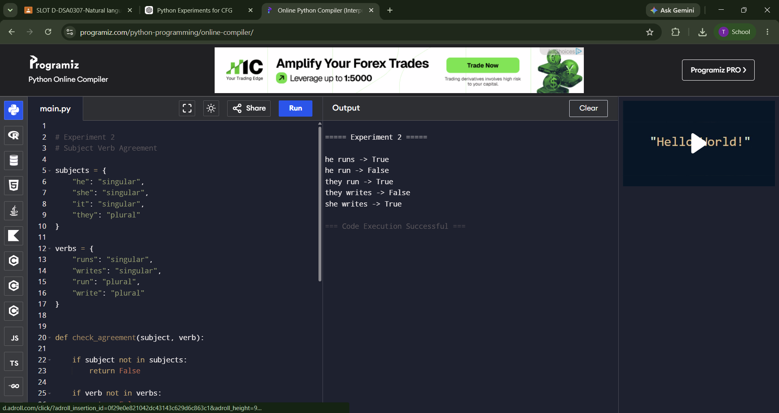
Test Cases
Subject | Verb | Output
he | runs | True
he | run | False
they | run | True
they | writes | False
she | writes | True

Result Analysis
- Correct subject–verb combinations return True.
- Incorrect grammatical combinations return False.
- Feature structures improve grammatical validation by checking Number and Person agreement.
- This technique is widely used in grammar checkers and NLP parsers.

Conclusion
The program correctly verifies subject–verb agreement using feature structures. It improves grammatical accuracy by validating linguistic constraints.

Experiment 3: Probabilistic Context-Free Grammar (PCFG)
Aim
To implement a Python program that computes the probability of a sentence using a Probabilistic Context-Free Grammar (PCFG).

Theory
A Probabilistic Context-Free Grammar (PCFG) extends CFG by assigning probabilities to production rules.
Grammar
S → NP VP [1.0]

NP → John [0.6]
NP → Mary [0.4]

VP → runs [0.5]
VP → walks [0.5]
Formula
P(Sentence)

= P(S → NP VP)
× P(NP)
× P(VP)

Algorithm
- Store grammar probabilities.
- Accept a two-word sentence.
- Split the sentence into NP and VP.
- Check whether both words exist in the grammar.
- Multiply the production probabilities.
- Display the sentence probability.
- If any word is not in the grammar, return 0.00.

Python Code and output:
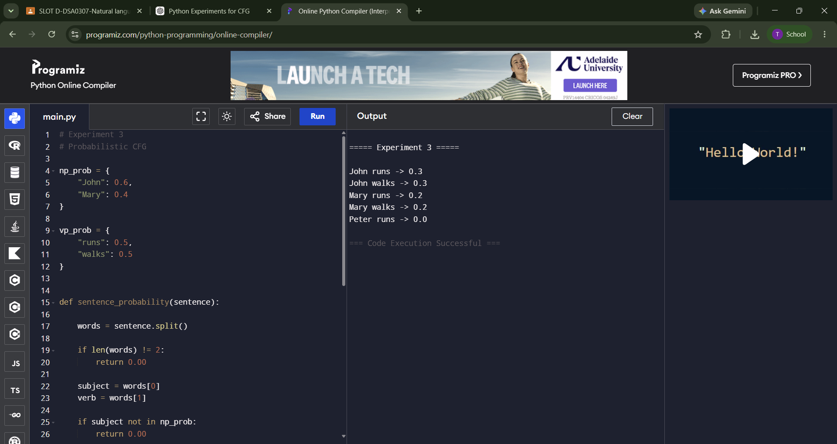
Test Cases
Sentence | Probability
John runs | 0.30
John walks | 0.30
Mary runs | 0.20
Mary walks | 0.20
Peter runs | 0.00

Result Analysis
- Sentence probabilities are computed by multiplying the production rule probabilities.
- Sentences not generated by the grammar receive probability 0.00.
- PCFG enables the parser to rank multiple possible parses based on likelihood.
- This approach is commonly used in speech recognition, machine translation, and syntactic parsing.

Conclusion
The experiment successfully computes sentence probabilities using PCFG production rules. It demonstrates how probabilistic parsing improves sentence interpretation in Natural Language Processing.

Rubrics for Calculation

Criteria | Weightage | Level 4 – Exemplary | Level 3 – Proficient | Level 2 – Developing | Level 1 – Beginning
Understanding of Concepts | 25 | Demonstrates thorough understanding and effectively integrates multiple concepts/technologies | Good understanding with proper integration of most concepts | Basic understanding; limited or partial integration | Poor understanding; unable to integrate concepts
Experimental Design | 30 | Well-planned, systematic implementation with optimal solution | Correct implementation with minor issues | Basic implementation with errors or inefficiencies | Incorrect or incomplete implementation
Use of Tools | 20 | Effective and advanced use of tools/technologies with proper configuration | Appropriate use of tools with correct execution | Limited or inconsistent use of tools | Incorrect or minimal use of tools
Analysis of Results | 15 | Insightful analysis with accurate interpretation and validation of results | Good analysis with reasonable interpretation | Basic analysis with limited insights | Poor or incorrect analysis of results
Documentation | 10 | Clear, well-structured documentation with diagrams, code, and results | Organized documentation with necessary details | Basic documentation with missing details | Poor or incomplete documentation

Q. No. / Criteria Level | Understanding of Concepts | Experimental Design | Use of Tools | Analysis of Results | Documentation | Sub. Total | Total %
1
2
3

Faculty In-charge | Course Coordinator | Program Director
Signature: _______________ | Signature: _______________ | Signature: _______________
Date: ___________________ | Date: ___________________ | Date: ___________________

